*C:\Program Files (x86)\Microsoft Office\MEDIA\CAGCAT10\j0300840.wmf***Judgment**

5 points/25 minutes

*Your task: Create a T-chart to evaluate whether a historical figure was good or bad.*

*Instructions:*

1. Make a T-chart listing **at least 7 things** the person said or did and list them as either good or bad. You must have at least 1 thing in both columns (do not just list 7 good things or 7 bad things.)

*Example*

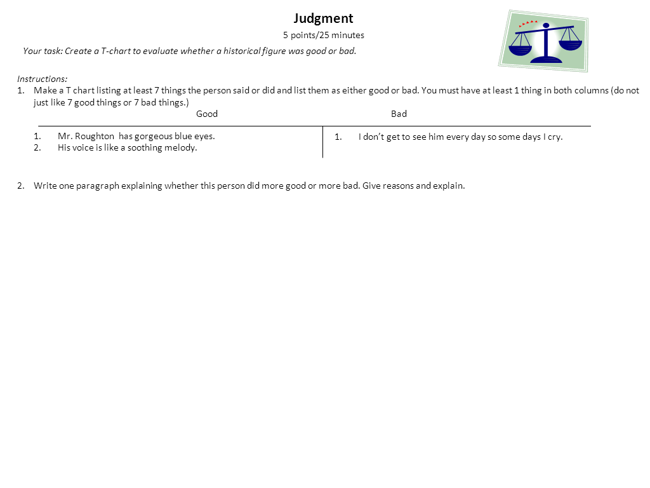

1. Write one paragraph explaining whether this person did more good or more bad. Give reasons from your chart and be sure to explain.

*C:\Program Files (x86)\Microsoft Office\MEDIA\CAGCAT10\j0300840.wmf***Judgment**

5 points/25 minutes

*Your task: Create a T-chart to evaluate whether a historical figure was good or bad.*

*Instructions:*

1. Make a T-chart listing **at least 7 things** the person said or did and list them as either good or bad. You must have at least 1 thing in both columns (do not just list 7 good things or 7 bad things.)

*Example*



1. Write one paragraph explaining whether this person did more good or more bad. Give reasons from your chart and be sure to explain.